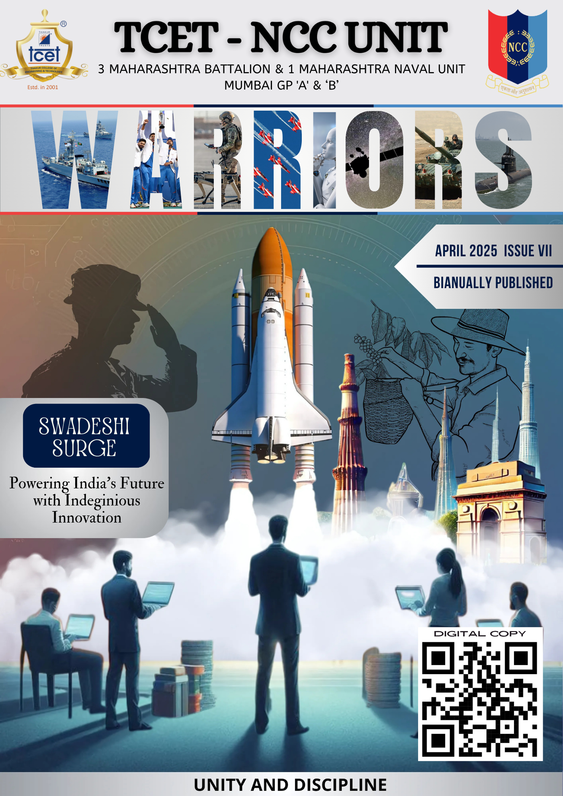 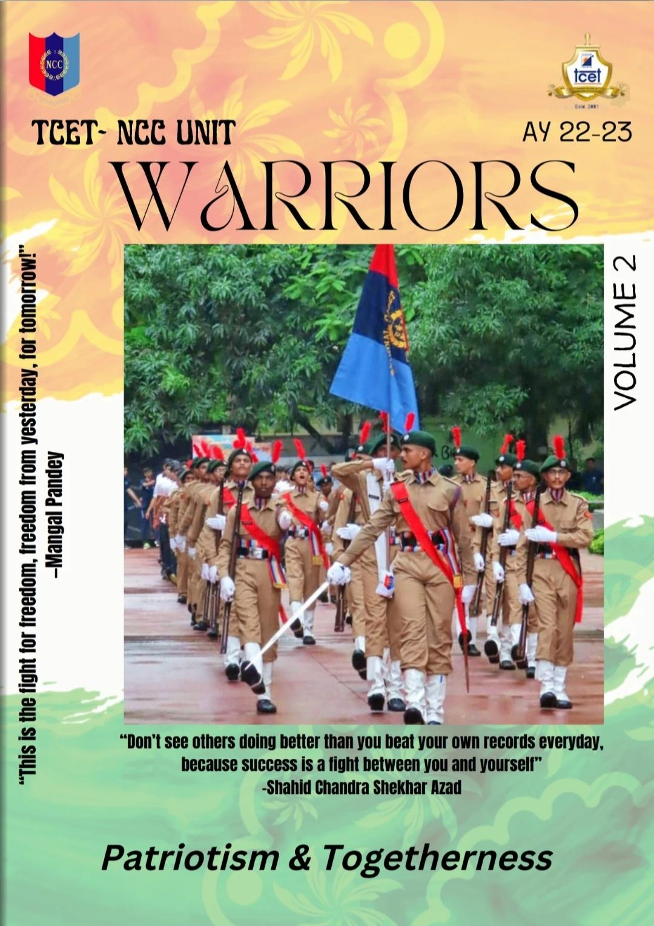

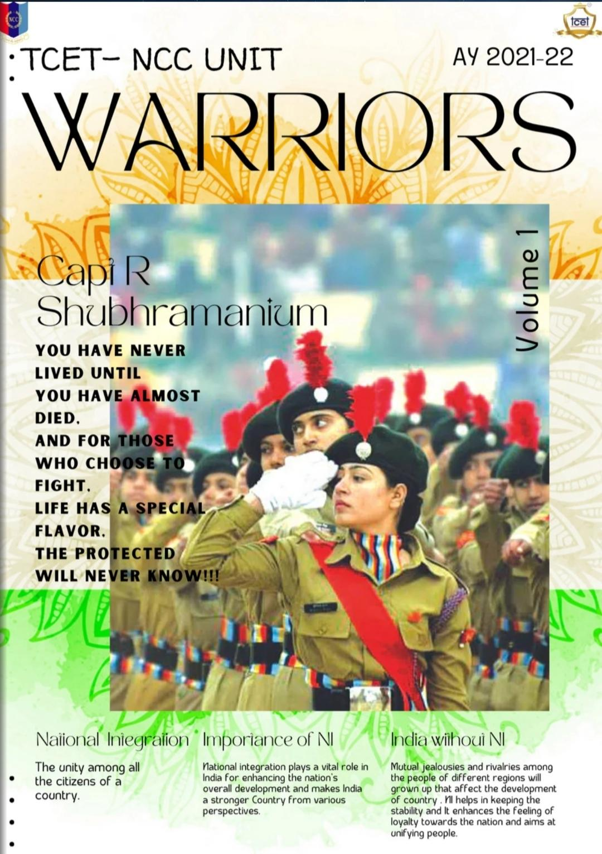 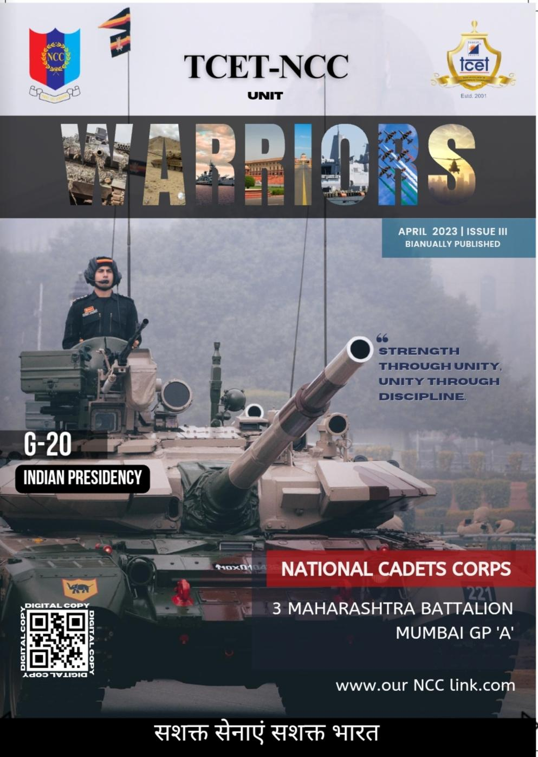

WARRIORS – April 2025 | 7th Edition of TCET NCC Magazine

The NCC Unit of Thakur College of Engineering and Technology is proud to release the 7th edition of its official biannual magazine, "WARRIORS", launched in April 2025. Guided by the 3 Maharashtra Battalion and 1 Maharashtra Naval Unit (Mumbai GP 'A' & 'B'), this edition reflects the NCC spirit of unity, discipline, and innovation.

Titled “Swadeshi Surge: Powering India’s Future with Indigenous Innovation,” the issue highlights India’s journey toward self-reliance, featuring themes of scientific growth, national pride, and youth-driven transformation. The cover blends ISRO’s achievements, iconic Indian heritage sites, and silhouettes of modern cadets—symbolizing a futuristic, Atmanirbhar Bharat.

The magazine captures the leadership, innovation, and dedication of TCET NCC cadets, inspiring fellow youth to uphold values of resilience and patriotism. This edition marks another milestone in shaping responsible, future-ready citizens.

Previous Edition Magazine: https://heyzine.com/flip-book/1e2383f07b.html